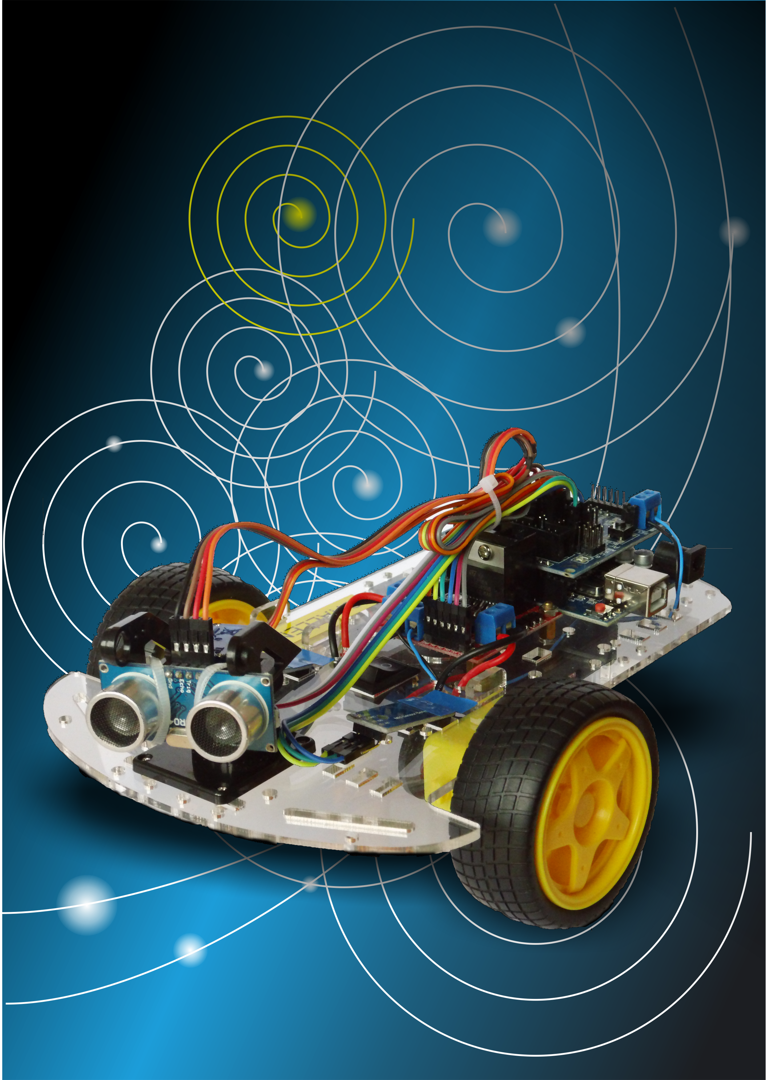

AUTONOMOUS ROBOT

CHALLENGE

Some place – January 26